## **What is ELT?**

ELT is a different method of looking at the tool approach to data movement. Instead of transforming the data before it's written, ELT lets the target system to do the transformation. The data first copied to the target and then transformed in place.

ELT usually used with no-Sql databases like Hadoop cluster, data appliance or cloud installation.

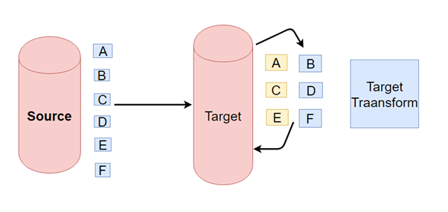

## **Difference between ETL vs. ELT**

ETL and ELT process are different in following parameters:

|  |  |  |
| --- | --- | --- |
| **Parameters** | **ETL** | **ELT** |
| **Process** | Data is transformed at staging server and then transferred to Datawarehouse DB. | Data remains in the DB of the Datawarehouse. |
| **Code Usage** | Used for   * Compute-intensive Transformations * Small amount of data | Used for High amounts of data |
| **Transformation** | Transformations are done in ETL server/staging area. | Transformations are performed in the target system |
| **Time-Load** | Data first loaded into staging and later loaded into target system. Time intensive. | Data loaded into target system only once. Faster. |
| **Time-Transformation** | ETL process needs to wait for transformation to complete. As data size grows, transformation time increases. | In ELT process, speed is never dependant on the size of the data. |
| **Time- Maintenance** | It needs highs maintenance as you need to select data to load and transform. | Low maintenance as data is always available. |
| **Implementation Complexity** | At an early stage, easier to implement. | To implement ELT process organization should have deep knowledge of tools and expert skills. |
| **Support for Data warehouse** | ETL model used for on-premises, relational and structured data. | Used in scalable cloud infrastructure which supports structured, unstructured data sources. |
| **Data Lake Support** | Does not support. | Allows use of Data lake with unstructured data. |
| **Complexity** | The ETL process loads only the important data, as identified at design time. | This process involves development from the output-backward and loading only relevant data. |
| **Cost** | High costs for small and medium businesses. | Low entry costs using online Software as a Service Platforms. |
| **Lookups** | In the ETL process, both facts and dimensions need to be available in staging area. | All data will be available because Extract and load occur in one single action. |
| **Aggregations** | Complexity increase with the additional amount of data in the dataset. | Power of the target platform can process significant amount of data quickly. |
| **Calculations** | Overwrites existing column or Need to append the dataset and push to the target platform. | Easily add the calculated column to the existing table. |
| **Maturity** | The process is used for over two decades. It is well documented and best practices easily available. | Relatively new concept and complex to implement. |
| **Hardware** | Most tools have unique hardware requirements that are expensive. | Being Saas hardware cost is not an issue. |
| **Support for Unstructured Data** | Mostly supports relational data | Support for unstructured data readily available. |

## **Summary:**

* ETL stands for Extract, Transform and Load while ELT stands for Extract, Load, Transform
* In ETL process data flows from the source to staging to the target.
* ELT lets the target system to do the transformation. No staging system involved.
* ELT address many a challenge of ELT but is expensive and requires niche skills to implement and maintain.